|  |
| --- |
| **Configuration UPS v1.1** |

Search UPS 1

Configure UPS Network Card (go to http://<ip>) 3

Configure Date/Time 5

Configure User 6

Configure Host Name 9

Upgrade Firmware NMC2 (only applicable for SRT6KXLI) 10

Configure Notifications 13

Configure Mail Server 13

Configure Recipients 15

Configure Event Actions 16

Configure SNMP 19

Configure SNMP traps 21

Change Shutdown Parameters 24

Deploy Powerchute OVA 26

Configure Powerchute 27

Runtime calibration 37

# Search UPS

Install and run the APC Device IP Configuration Wizard

Or set a static IP@ on through the display of the UPS

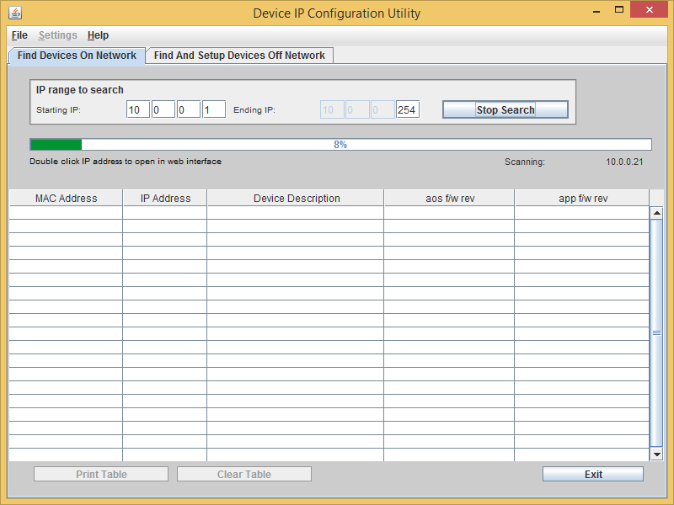

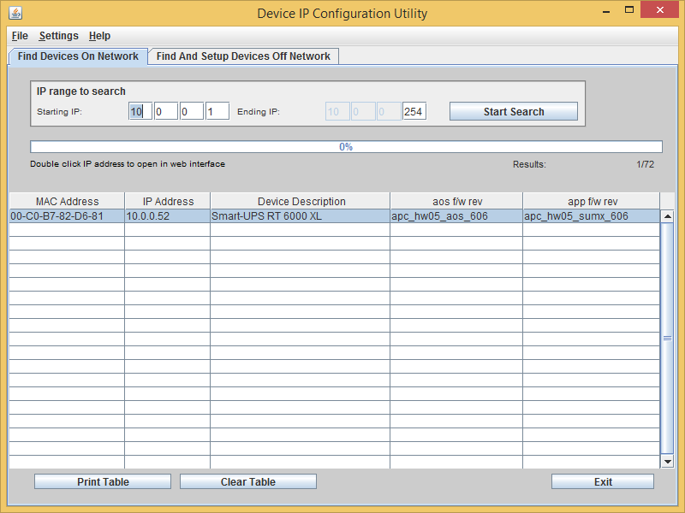

Login on the UPS by using:

Login: apc | Password: apc

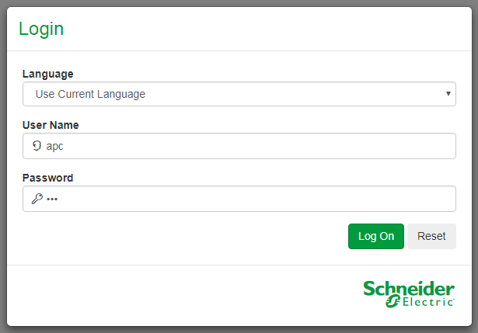

# Configure UPS Network Card (go to http://<ip>)

Configuration >> Network >> TCP/IP >> IPv4 Settings

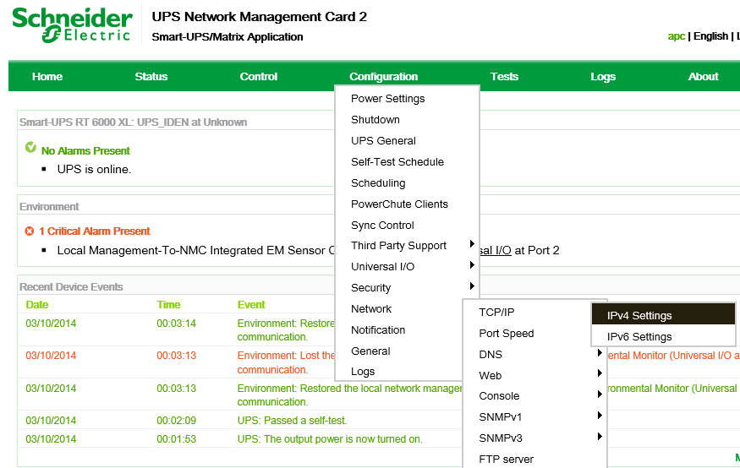

Set as IP@ X.X.X.246

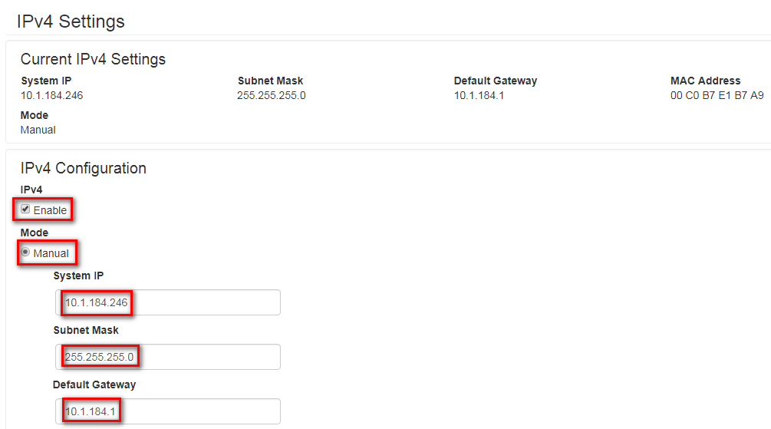

Reboot the UPS system to apply the settings

Control >> Network >> Reset/Reboot

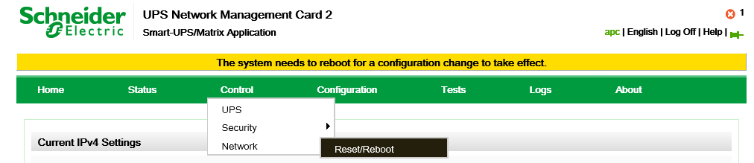

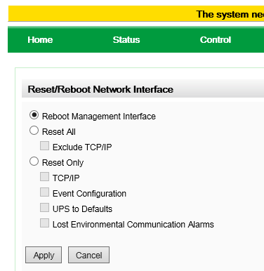

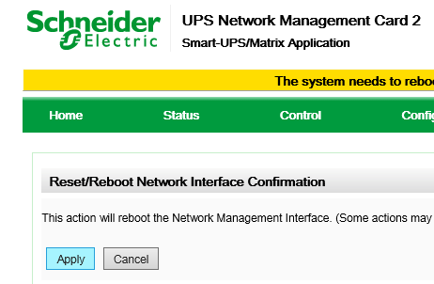

# Configure Date/Time

Configuration >> General >> Date/Time >> Mode

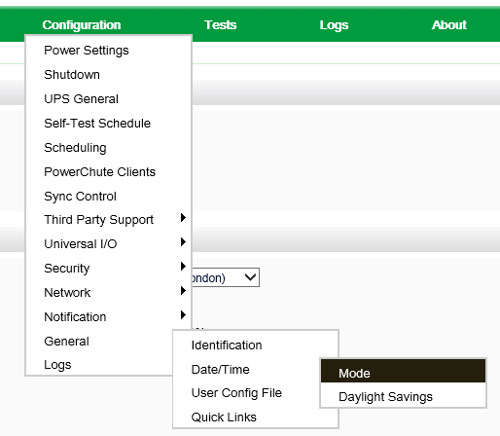

Fill in the information as below

Primary NTP Server > X.X.X.11 | Secondary NTP Server > 10.128.1.72

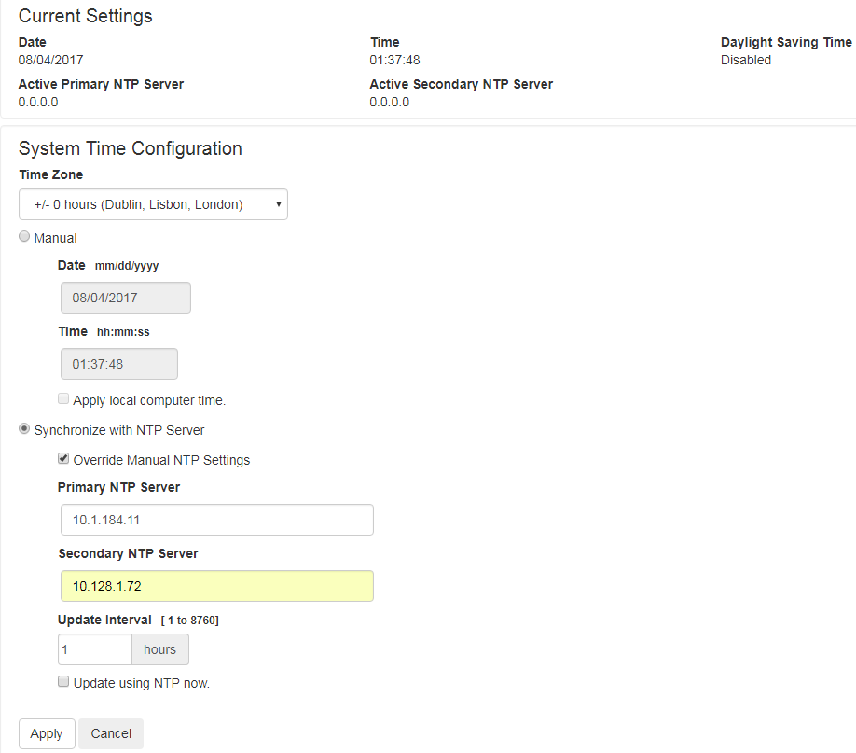

# Configure User

Configuration >> Security >> Local Users >> Management

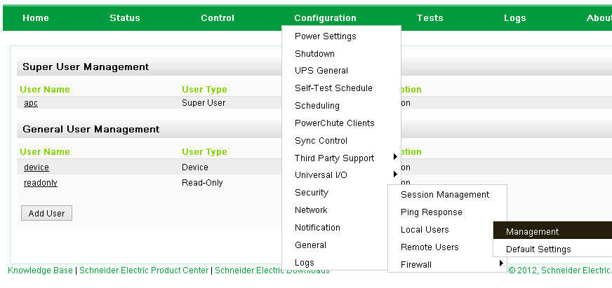

Click apc

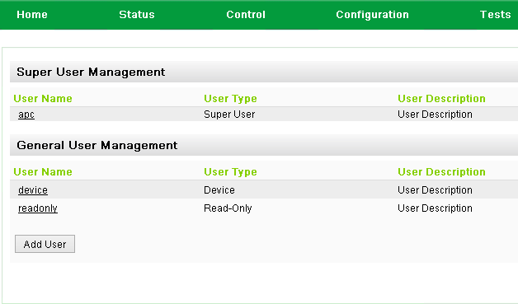

Fill in the information as the example below << Password needs to be the same as administrator

>> Edit the information in RDM

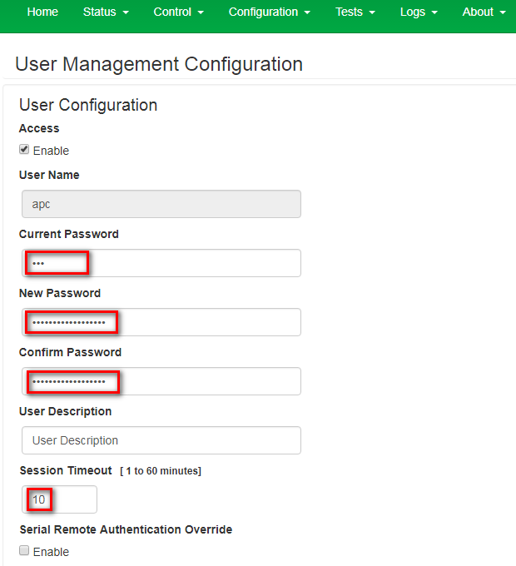

Next >> Apply

Click [Add User]

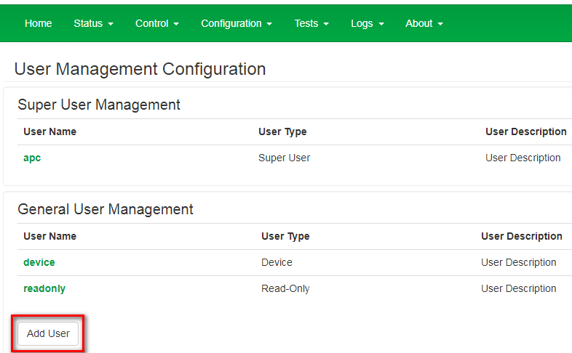

Fill in the information as the example below << Password needs to be the same as the domain srv_ups account

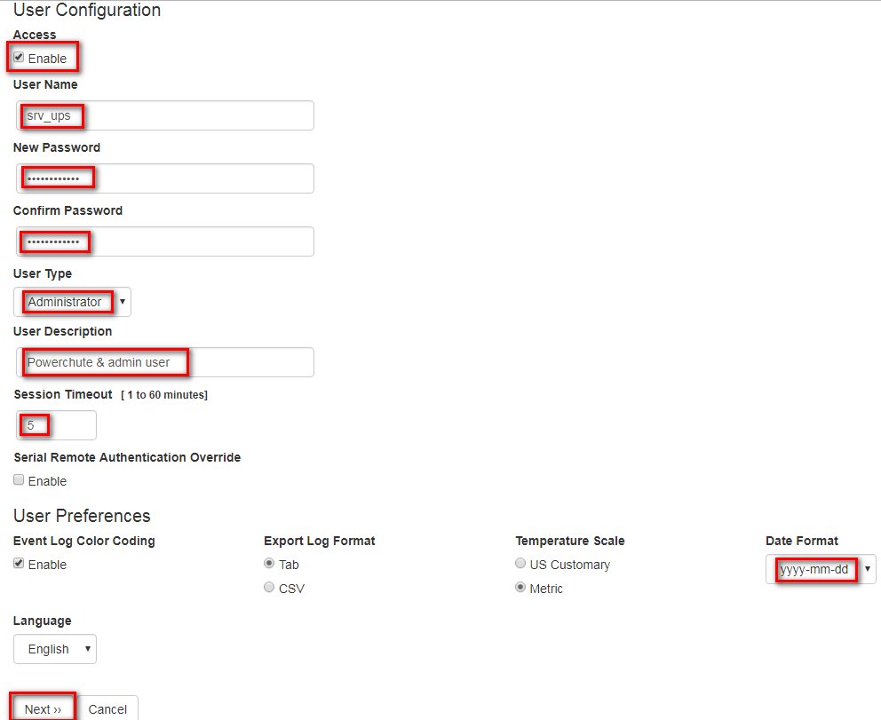

# Configure Host Name

Configuration >> General >> Identificaton

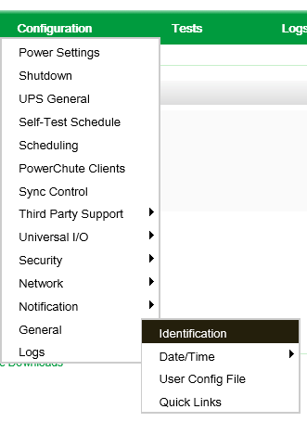

Fill in the information as the example below

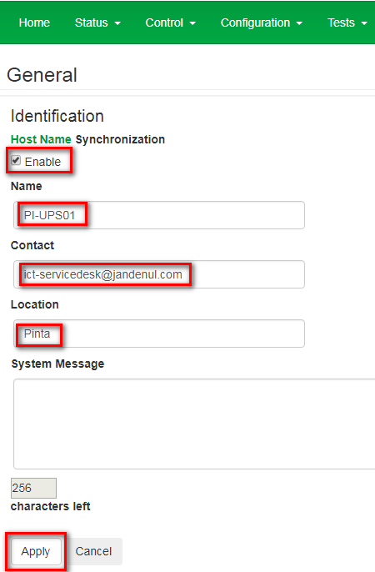

Click Apply

# Upgrade Firmware NMC2 (only applicable for SRT6KXLI)

Copy the file NMC2 v6.5 from \\Jdn-file01\ict_new_standard_sites_vessels\Firmware\Current\Apc SRT6KXLI

to the root of XX-MGMT01

On the XX-MGMT01 go to NMC2 V6.5 and start FW_Upgrade_R2

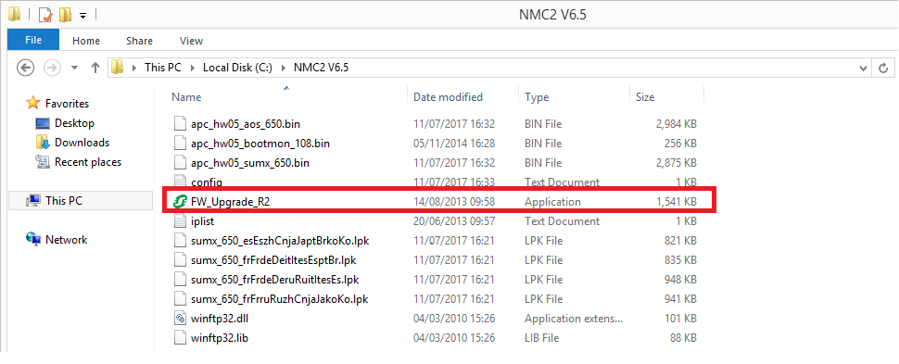

Insert IP Address x.x.x.246 where x is the admin trust range and the srv_ups credentials.

Use the ping button to make sure that the NMC is reachable

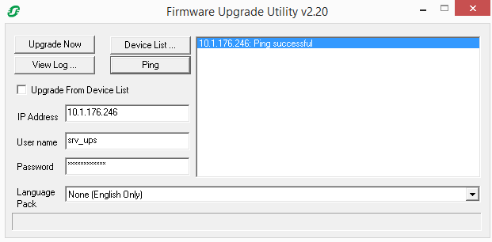

Output should look something like this

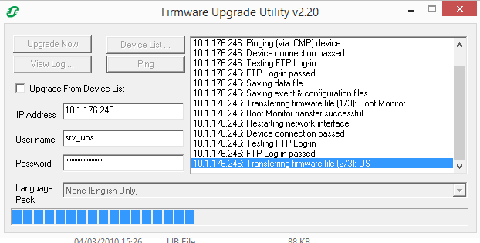

When all is completed you should get the following

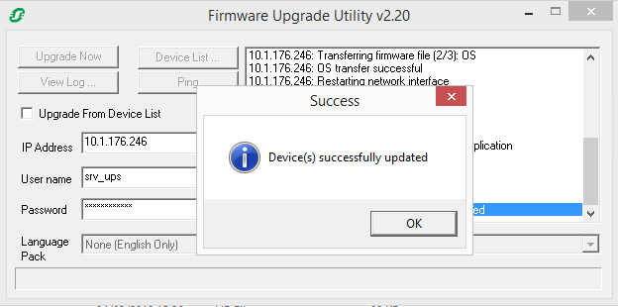

To make sure that it’s been successfull go to http://x.x.x.246

About => Network

The current versions should be as shown on screenshot, if lower then redo the upgrade.

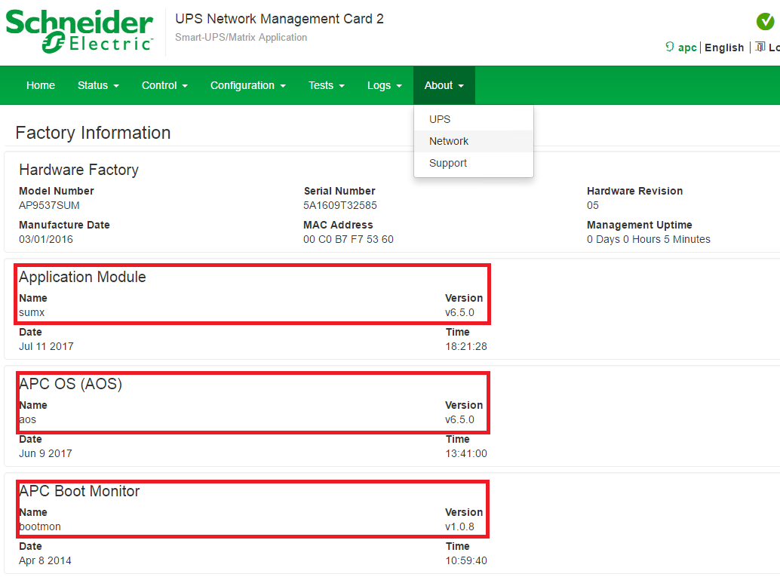

# Configure Notifications

## Configure Mail Server

Configuration >> Notification >> E-mail >> Server

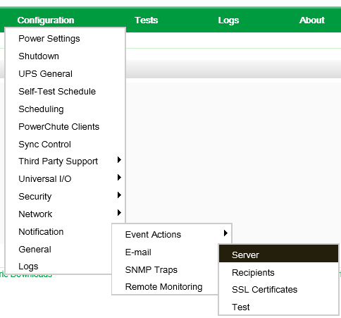

Click Active Primary DNS Server

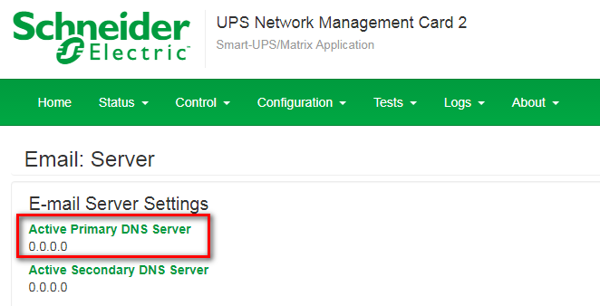

Fill in the information as the example below Primary DNS Server > X.X.X.11

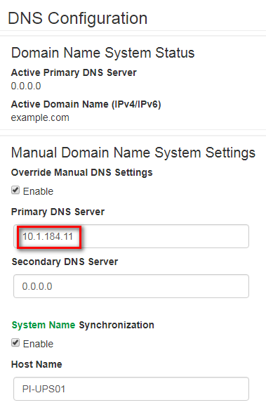

Configuration >> Notification >> E-mail >> Server

Fill in the information as the example below

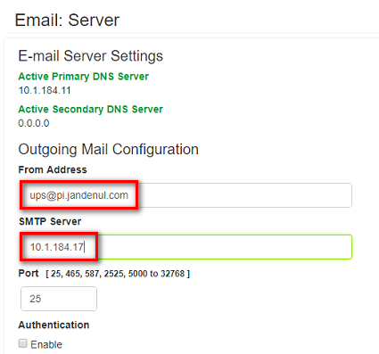

Note: if the domain is JDN-integrated, make sure to enter the correct smtp.jandenul.com as SMTP Server

## Configure Recipients

Configuration >> Notification >> E-mail >> Recipients

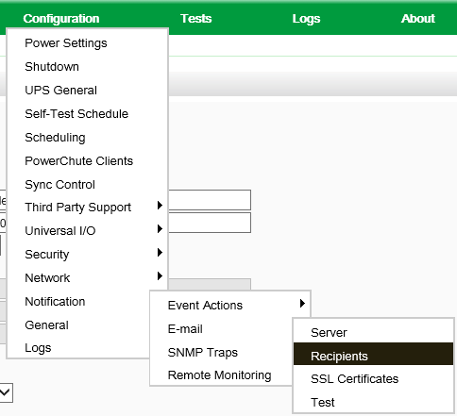

Click Add

Fill in the information as the example below

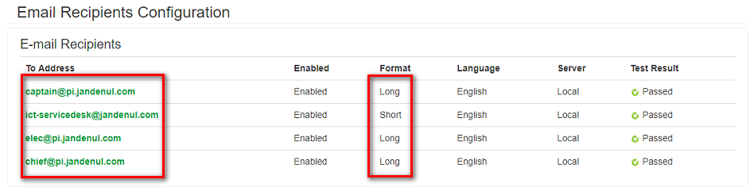

## Configure Event Actions

Configuration >> Notification >> Event Actions >> By Group

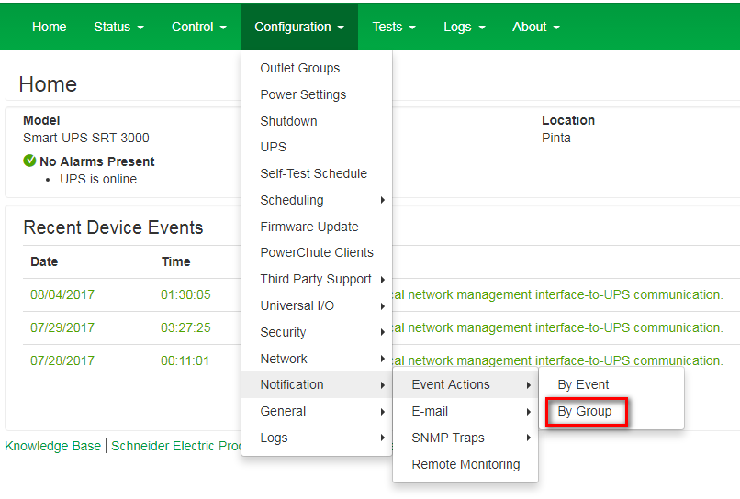

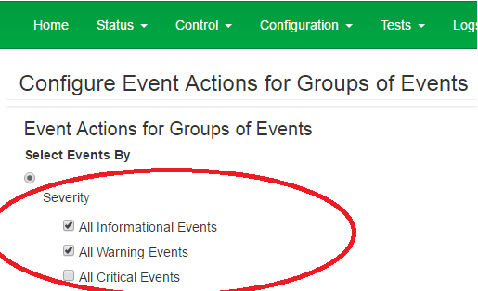

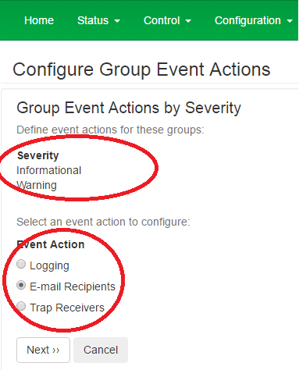

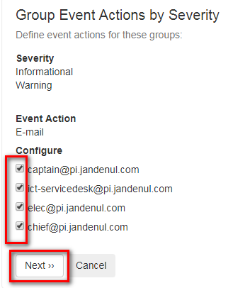

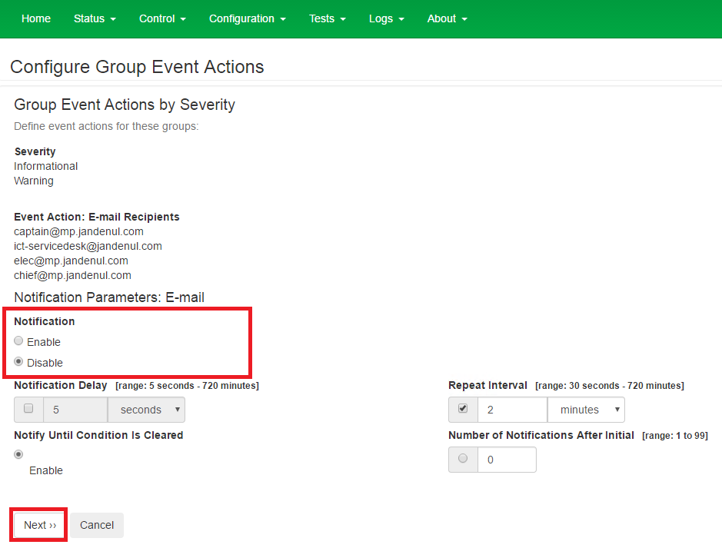

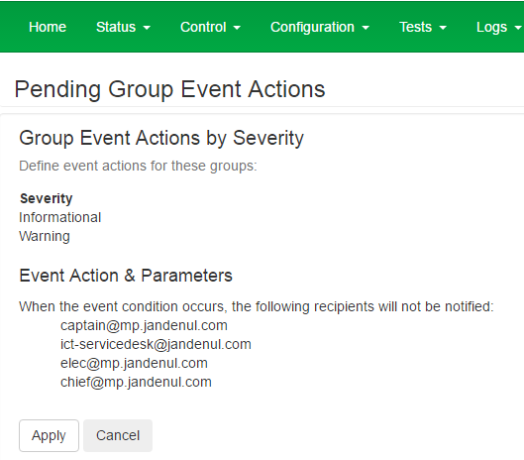

Click [Finish]

Configuration >> Notification >> Event Actions >> By Events

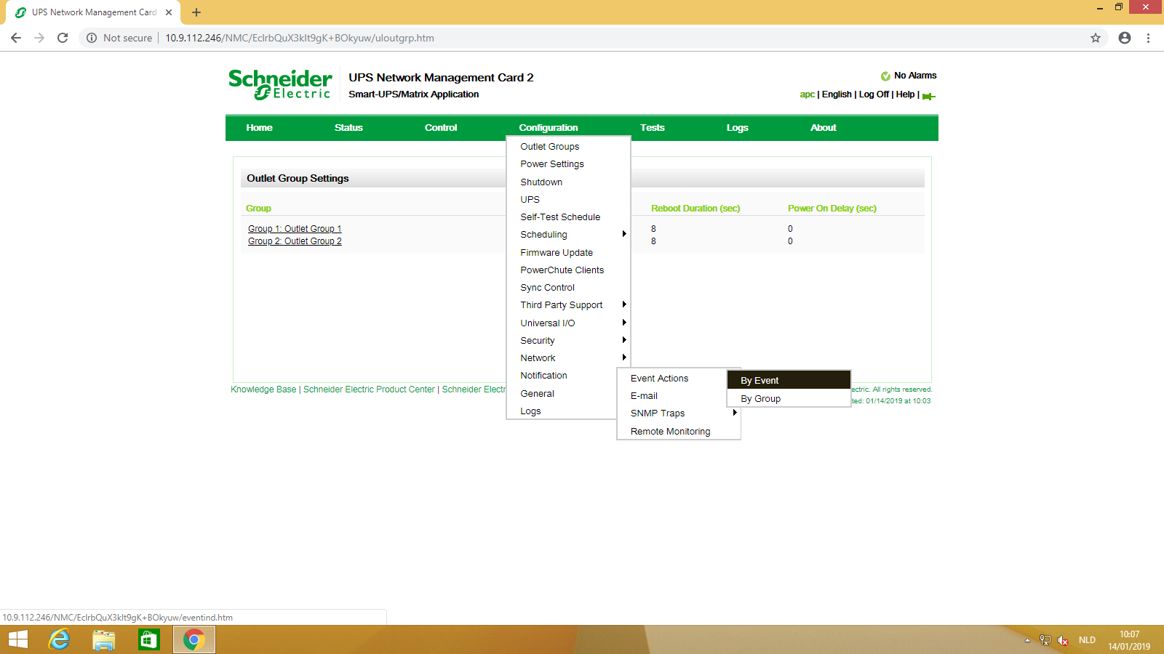

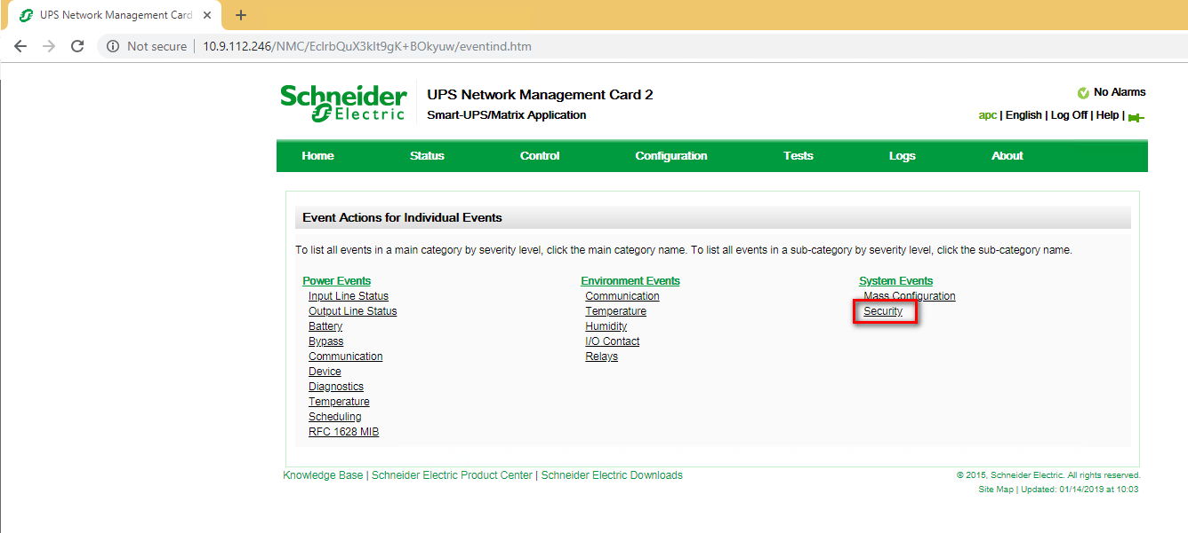

Disable e-mail notification for everything concerning user access.

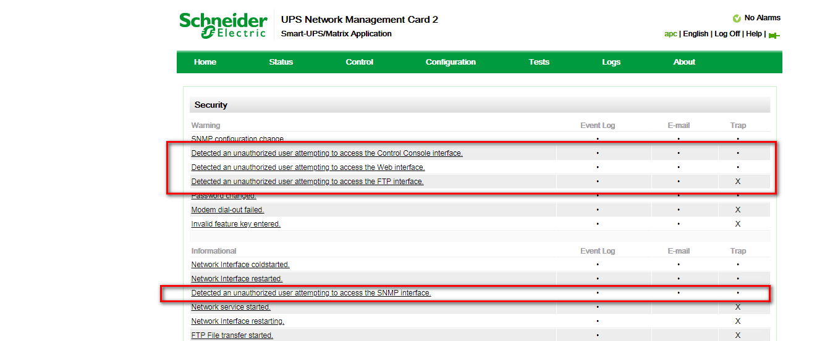

Uncheck e-mail notification, click [Apply]

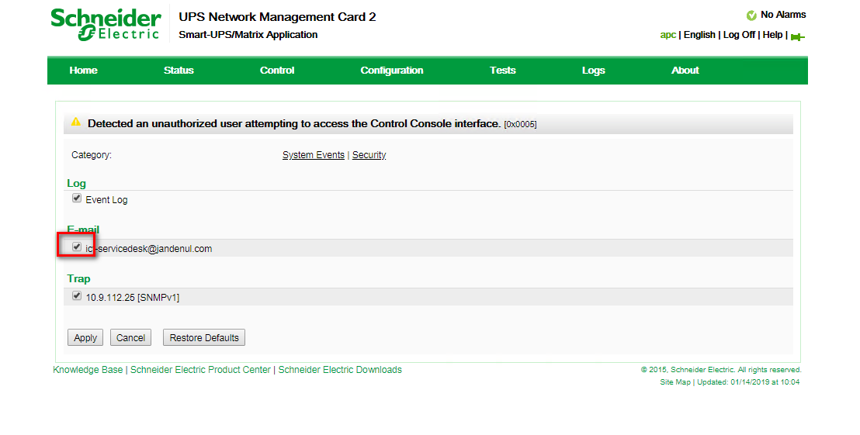

# Configure SNMP

Configuration >> Network >> SNMPv1 >> Access Control

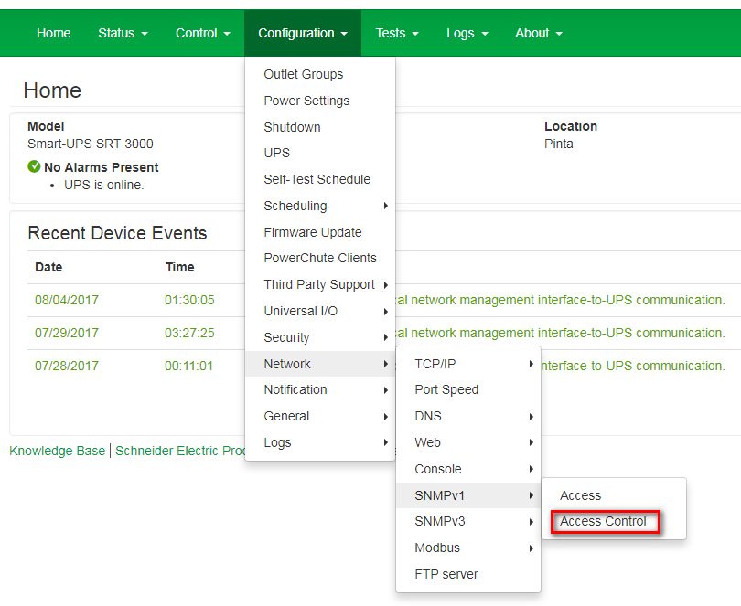

Click [Publick]

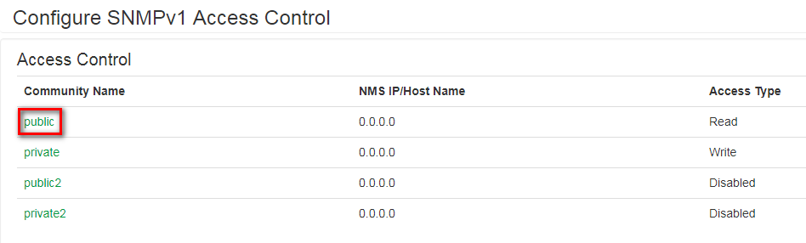

Fill in the information as the example below>> Community Name >> SNMP-RO

Hostname >> X.X.X.25

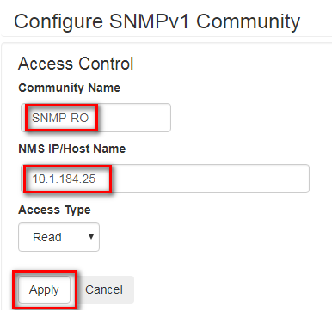

Result:

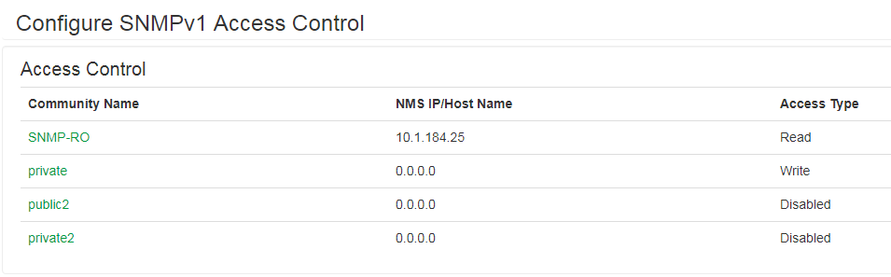

# Configure SNMP traps

Configuration >> Notification >> SNMP Traps >> Trap Receivers

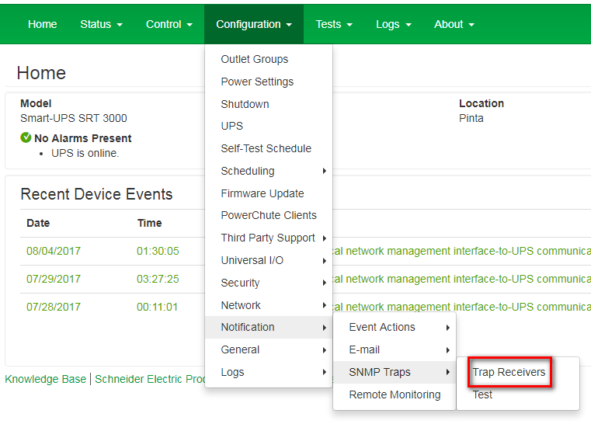

Add Trap Receiver

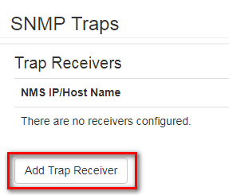

IP: X.X.X.25

Community name (SNMPv1): SNMP-RO

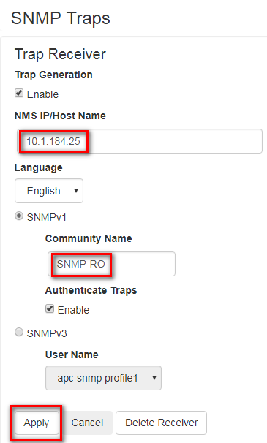

Apply

Configuration >> Notification >> SNMP Traps >> Test

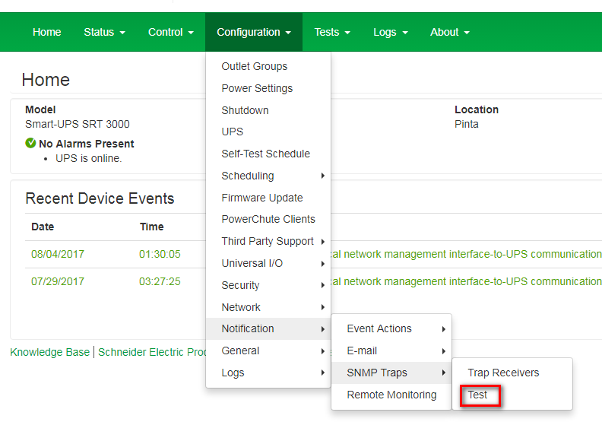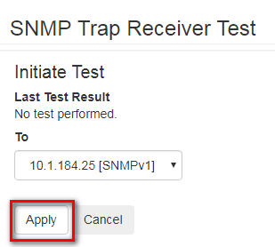

Check the PRTG SNMP Trap Receiver

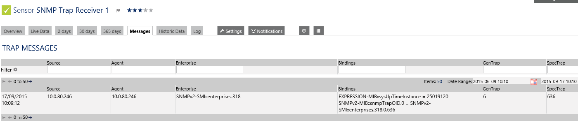

# Change Shutdown Parameters

Configuration >> Shutdown

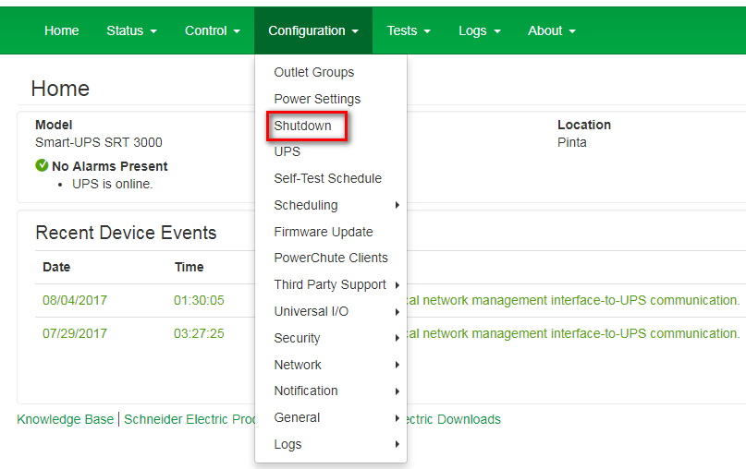

Select user Name: SRV_UPS

Authentication Phrase: JanDeNulUPSAuthPhrase

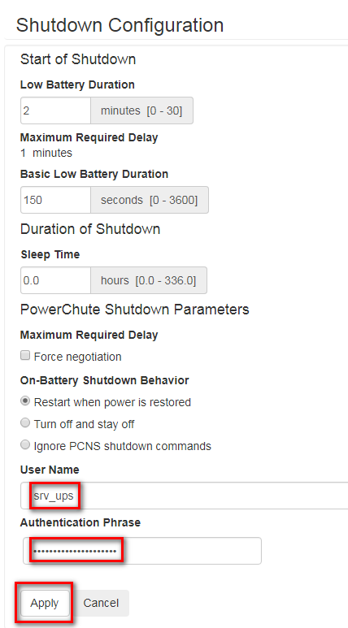

# Deploy Powerchute OVA

If you used the scripted install procedure, the Powerchute OVA will have been deployed. If not, deploy the OVA manually, and assign IP address x.x.x.21 to the Powerchute VM.

Browse to X.X.X.10

Open VMware Remote Console of XX-UPSMGMT01

This is all in QWERTY

Use option [1] and type in Administrator Password << !QWERTY!

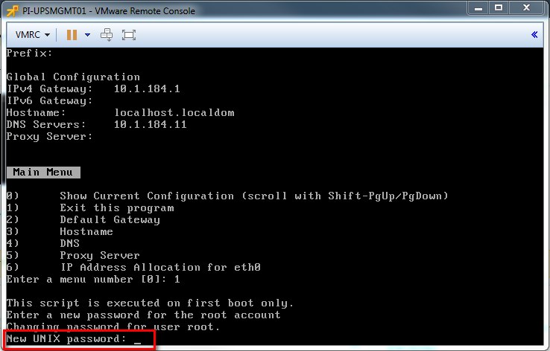

# Configure Powerchute

Go to <https://X.X.X.21:6547>

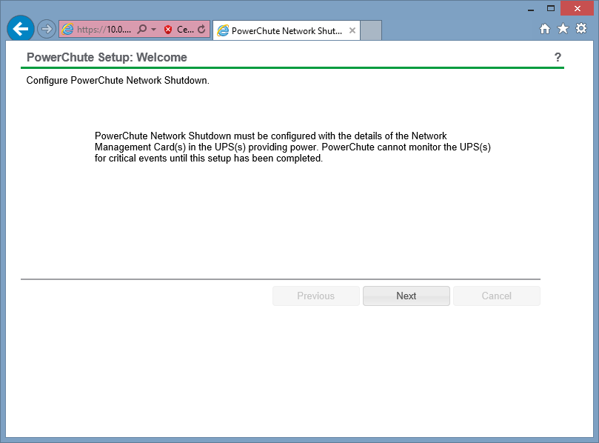

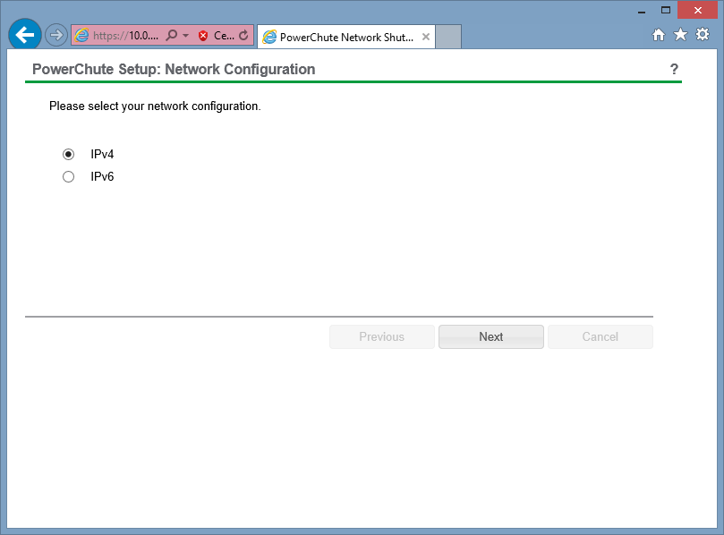

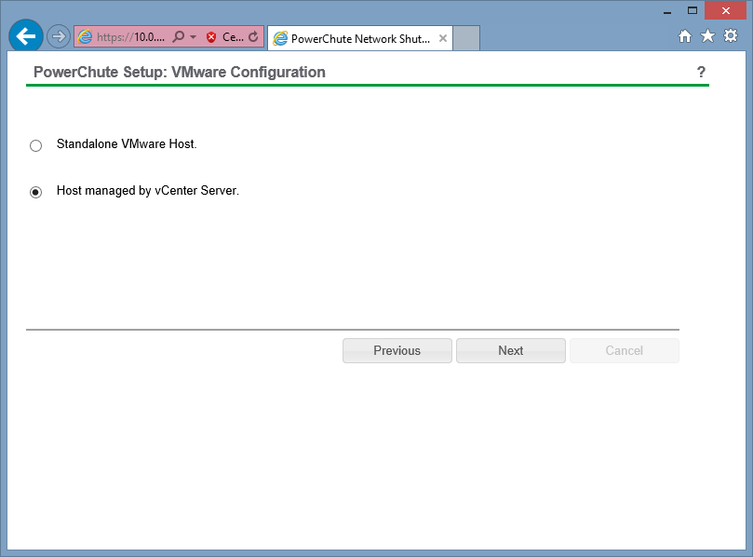

Fill in the information as the example below

IP@ > X.X.X.10

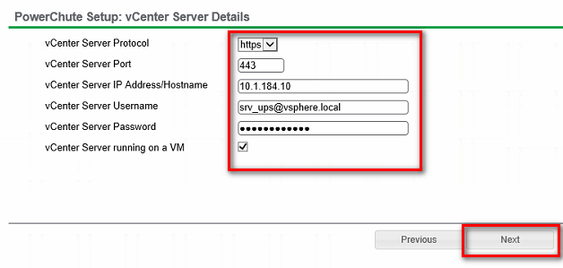

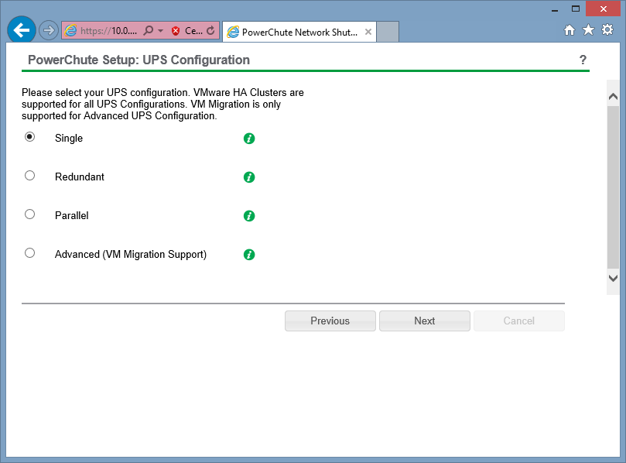

Fill in the information as the example below

Authentication phrase: JanDeNulUPSAuthPhrase

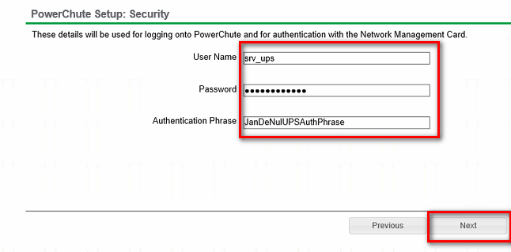

Fill in the information as the example below >> IP@ > X.X.X.246

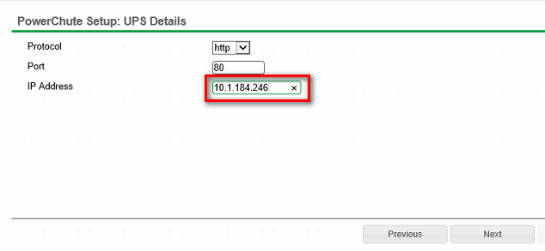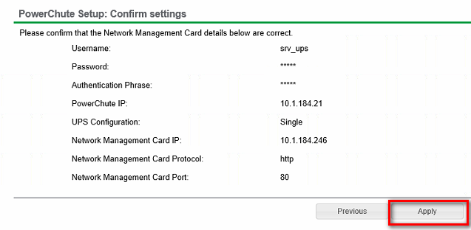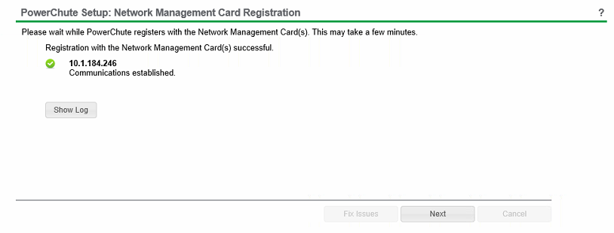

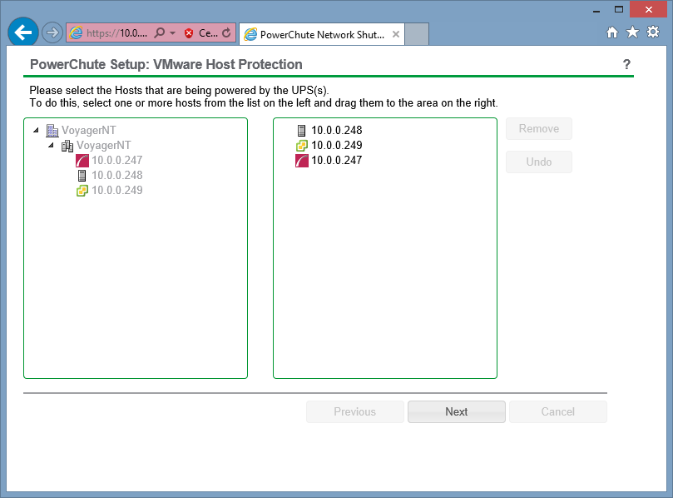

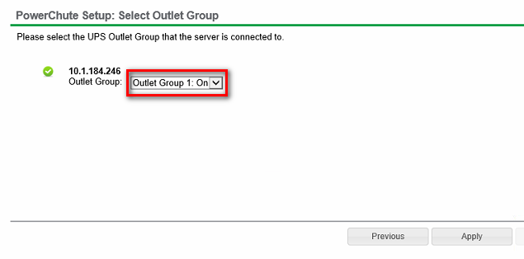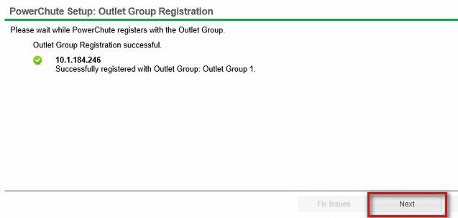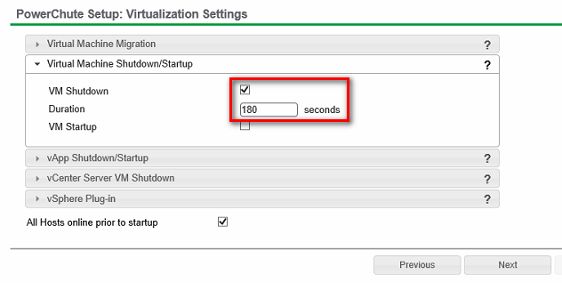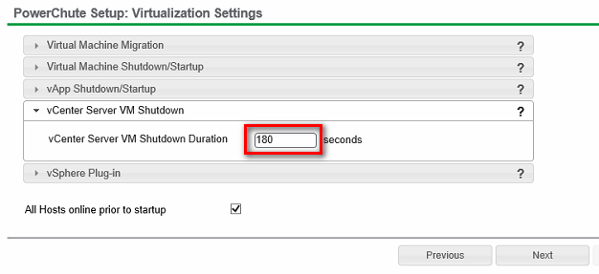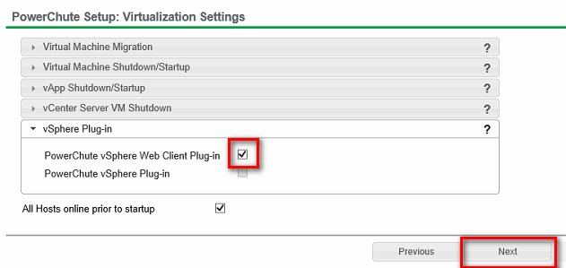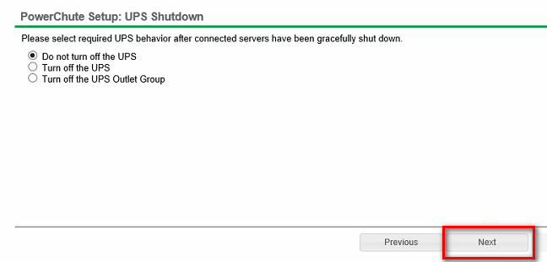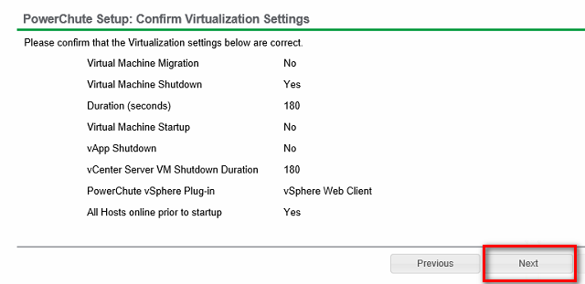

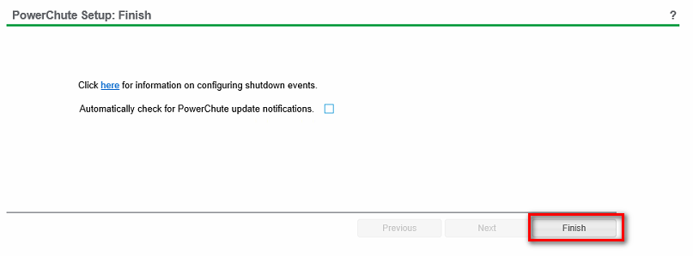

# Runtime calibration

When your UPS is configured, you should perform a runtime calibration.

Browse to X.X.X.246

Make sure the battery is fully charged and the whole setup is using the UPS as power source

Tests >> UPS

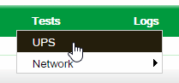

Select [Runtime calibration] and click [Apply]

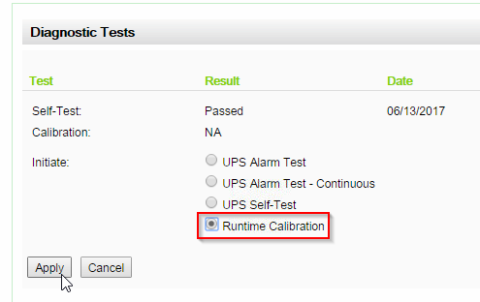

While the calibration is running, the UPS will start beeping, which can be annoying for people in the same room. To switch this off, go into the same menu again or refresh the page and afterwards, select 'Mute UPS Alarm'

